NATIONAL JUNIOR COLLEGE
PRELIMINARY EXAMINATIONS
Higher 1
CANDIDATE
NAME

SUBJECT  CLASS |  | REGISTRATION NUMBER

CHEMISTRY  Paper 2 Structured Questions | 8872/02  13 Sept 2010  2 hours

READ THE INSTRUCTION FIRST  Write your subject class, registration number and name on all the work you hand in.  Write in dark blue or black pen on both sides of the paper.  You may use a soft pencil for any diagrams, graphs or rough working.  Do not use paper clips, highlighters, glue or correction fluid.  Section A  Answer all questions.  Section B  Answer any two questions.  At the end of the examination, fasten all your work securely together.  The number of marks is given in brackets [ ] at the end of each question or part question.  This question paper consists of 14 printed pages (including this page). | For Examiner’s Use
 | Section A
 | A1
 | A2
 | A3
 | A4
 | A5
 | Section B
 | B1
 | B2
 | B3
 | Total

Section A
Answer all the questions in this section in the spaces provided.

1 | Butanoic acid, CH₃CH₂CH₂COOH (M_{r} = 88.0), also known as butyric acid have important uses in the industry, such as perfume and food additives.  In an experiment, a 10.0 cm³ sample of butanoic acid of concentration 0.025 mol dm³ was titrated against 0.010 mol dm⁻³ barium hydroxide, Ba(OH)₂.
 | (a) | Calculate the volume of barium hydroxide, Ba(OH)₂ required for the neutralization of butanoic acid in the experiment.  2 CH₃CH₂CH₂COOH + Ba(OH)₂ → (CH₃CH₂CH₂COO)₂Ba + 2 H₂O  No. of moles of butanoic acid = 10.0 x x 10⁻³ x 0.025 = 2.5 x 10⁻⁴  No. of moles of Ba(OH)₂ = ½ (2.5 x 10⁻⁴) = 1.25 x 10⁻⁴  Volume of Ba(OH)₂ = 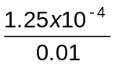x 1000 = 12.50 cm³  [2]
 | (b) | Write an expression for the acid dissociation constant, K_{a} for butanoic acid. Hence, determine its K_{a} value given that the initial pH of butanoic acid is 3.2.  K_{a} = 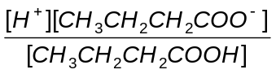  K_{a} = (10^{−3.2})² / (0.025 − 10^{−3.2}) = 1.59 × 10⁻⁵ mol dm⁻³  [2]
 | (c) | Another experiment was conducted to determine the enthalpy change of reaction between butanoic acid and barium hydroxide.  Given the following data, determine the enthalpy change of reaction for the above reaction.  Volume of 3.00 mol dm⁻³ barium hydroxide = 30.0 cm³  Volume of 2.00 mol dm⁻³ butanoic acid = 40 cm³  Temperature rise = 14.9 °C  Specific heat capacity of water = 4.18 J g⁻¹ K⁻¹  2 CH₃CH₂CH₂COOH + Ba(OH)₂ → (CH₃CH₂CH₂COO)₂Ba + 2 H₂O  No. of moles of butanoic acid = 2 x 40 x 10⁻³ = 0.08  No. of moles of barium hydroxide = 30 x 10⁻³ x 3 = 0.09  0.08 moles of butanoic acid requires 0.04 moles of barium hydroxide for reaction, thus butanoic acid is limiting.  Heat evolved = 70 x 4.18 x 14.9 = 4360 J  ΔH = −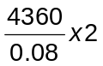= − 109 kJ mol  [2]
 | (d) | Predict and explain how the magnitude of the temperature rise will change when the reaction in (c) as repeated using 2-chlorobutanoic acid with the same volume and concentration as butanoic acid.  Temperature rise would be larger. 2-chlorobutanoic acid is a stronger acid and dissociates more than butanoic acid, thus, less of the energy evolved from neutralization would be used up to fully dissociate 2-chlorobutanoic acid. Since more heat would be evolved for the neutralization of 2-chlorobutanoic acid, the temperature rise would be larger  [2]  [Total: 8]

2 | The first seven ionisation energies of Element A from Period 2 are as follows:
  No of electrons lost | 1st | 2nd | 3rd | 4th | 5th | 6th | 7th
  Ionisation energy/  kJ mol⁻¹ | 1410 | 2866 | 4576 | 7473 | 9442 | 53250 | 64340
 | (a) | Deduce the group that Element A belongs to in the Periodic Table. Explain your answer.  Largest jump in I.E is from 5th to 6th IE, thus A is in group V. There are 5 valence electrons, the 6th electron is in an inner principal quantum shell nearer the nucleus, thus require much more energy to remove due to stronger attraction to the nucleus.  [2]
 | (b) | State the identity of Element A and hence write its electronic configuration.  A is nitrogen. Configuration = 1s² 2s² 2p³  [1]
 | (c) | Magnesium reacts with A to form an ionic compound of the formula Mg₃A₂. State and explain which one of the ions in the compound would have a larger ionic radius.  Ions are Mg²⁺ and N³⁻  Both ions are isoelectronic, but Mg²⁺ has more protons than N³⁻. The valence electrons of Mg²⁺ would be more strongly attracted towards the nucleus, leading to a smaller ionic radius.  [2]  [Total: 5]

3 | (a) | The boiling points of some compounds are given in the table below.
  Compounds | M_{r} | Boiling Points / °C
  Lithium chloride | 42.5 | 1382
  Lithium iodide | 134 | 462
  Ammonia | 17 | − 33
  Hydrogen fluoride | 20 | 19.5
  Iodine | 254 | 185
 | (ii) | Explain the difference in the boiling point between  I. lithium chloride and lithium iodide  LE α 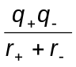  Both cations and anions have the same charge. However, Cl⁻ has a smaller ionic radius than I⁻. Thus, the interionic distance between Li⁺ and I⁻ is greater than between Li⁺ and Cl⁻.  Lattice energy of LiCl more exothermic than LiI. Ionic bonds in LiI is stronger than in LiCl, leading to a larger boiling point as more energy required to break stronger ionic bonds between Li⁺ and Cl⁻.  [2]
II. ammonia and hydrogen fluoride

F is more electronegative than N, thus making the H attached to F in HF more protonic. This leads to stronger hydrogen bonds between the lone pair on F of one HF molecule with the protonic hydrogen of another HF molecule as compared to that between NH₃.
Thus, more energy required to break the stronger hydrogen bonds between HF molecules compared to NH₃ molecules.
[2]
III. iodine and hydrogen fluoride.

The temporary dipole induced dipole forces between I₂ molecules is much stronger than the hydrogen bonds between HF molecules as I₂ has a much larger electron cloud, leading to greater polarisability. Thus, more energy required to break the stronger temporary dipole induced dipole forces between I₂ molecules.
[2]

[Total: 6]

4 | (a) | An organic compound B of the molecular formula C₄H₆O, undergoes a series of reactions as shown by the table below. State the deductions for each of the following reactions.
Test | Deductions
(I) Brown precipitate is observed when cold dilute alkaline KMnO₄ is added to 1 cm³ of a solution containing B in a test-tube. | C=C bond is present, mild oxidation with KMnO₄ to form a diol.
(II) Silver mirror is observed when Tollen’s reagent is added to 1 cm³ of a solution containing B in a test-tube. | Aldehyde group is present. Tollen’s reagent oxidize aldehyde to carboxylate, Ag⁺ reduced to Ag mirror.
(III) 0.1 mole of compound B will react with 4.8 dm³ of hydrogen gas in the presence of a platinum catalyst at room temperature and pressure. | No. of moles of H₂ = 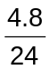= 0.2 moles  Reduction of C=C and aldehyde group to form alkane and 1º alcohol group.
[4]

 | (b) | Compound B exhibits geometric isomerism. Together with the information obtained in (a), give the structural formula of B.  B: CH₃CH=CHCHO  [1]
 | (c) | State the structural features present in compound B that enables it to exhibit geometric isomerism. Hence draw the geometric isomers of B.  - C=C to restrict free rotation  - The two groups attached to the same C of the carbon-carbon double bond are different.  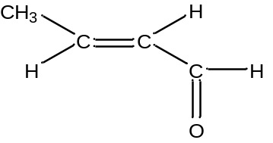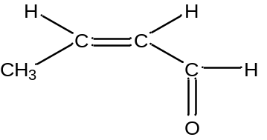  Trans isomer cis isomer  [2]
 | (d) | Compounds C and D have the same molecular formula C₄H₆O. Both gives the same positive test as shown in (a). C and D are structural isomers of one another but they do not exhibit geometric isomerism. Draw the structures for compounds C and D.  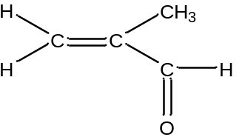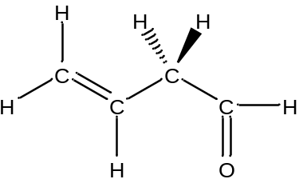  C D  [2]
 | (e) | Suggest a test-tube reaction to differentiate compound B from either C or D. State the reagents and conditions used and the observations for each of the compounds.  KMnO₄, H₂SO₄, heat  B: Purple KMnO₄ decolourises  C&D: Purple KMnO₄ decolourises and effervescence observed.  [2]  [Total: 11]
5 | Methane, one of the main components in natural gas is an important fuel used worldwide. It has an enthalpy change of combustion of −890 kJ mol⁻¹.  Methane is being depleted at an alarming rate. The current worldwide consumption of methane is about 4.9 x 10⁹ m³ per year. Thus, alternative sources of methane need to be sought to sustain the world’s consumption.  One of the alternative sources of methane comes in the form of methane hydrate. It is also known as methane ice or fire ice in which a large amount of methane is trapped within the crystal structure of ice. Part of the crystal structure of ice is shown below.  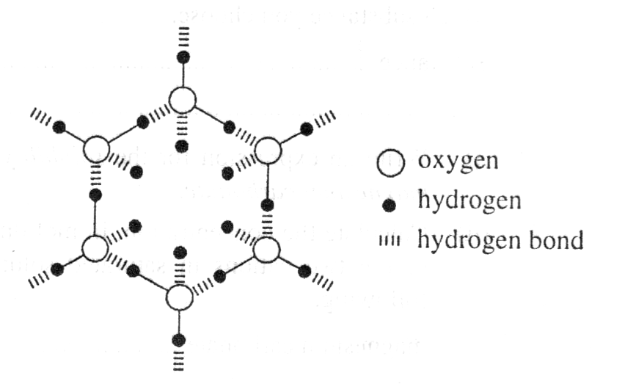  Larger hydrocarbon molecules such as ethane and propane can also form hydrates, although as the molecule length increases (butanes, pentanes), the tendency to form hydrates decreases.  Significant deposits of methane hydrate are found under sediments on the ocean floors and the arctic permafrost of the Earth, about 500 to 2000 m below the ocean surface. It is estimated that there are 11.3 x 10¹⁸ m³ of methane hydrate available worldwide.  Thus, international research and exploration by governmental and industrial entities evaluated that methane hydrates could be important primary energy sources in the future due to the depletion of fossil fuels. To utilize the methane in methane ice, excavators would likely melt the ice underground first, and then extract the methane gas. When brought to the surface, it is estimated that 1 m³ of methane hydrate contains about 180 m³ of methane, measured at room temperature pressure.  Although methane hydrate is plentiful throughout the world, there are many key challenges being faced in the utilizing of methane hydrate as a source of methane. With these challenges in mind, China's Ministry of Land and Resources estimated that the country could begin using its combustible ice within 10 to 15 years, joining other countries in methane hydrate exploration.  Water gas, which consists of an equimolar mixture of hydrogen and carbon monoxide is another type of fuel used in the industries. The enthalpy of combustion of hydrogen and carbon monoxide are −242 kJ mol⁻¹ and −283 kJ mol⁻¹ respectively.  Water gas could be produced according to the following equation.  H₂O (g) + C(s) → H₂ (g) + CO (g)  It is a useful product but requires careful handling because of the risk of carbon monoxide poisoning.
 | (a) | Calculate the amount of energy that can be produced from the methane extracted from 1 m³ of methane hydrate.  Volume of methane = 180 m³  No. of moles of methane = 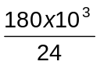= 7500 moles  Energy evolved = 7500 x 890 = 6.68 x 10⁶ kJ  [2]
 | (b) | Calculate the volume of methane that can be obtained at room temperature and pressure from the methane hydrate available worldwide.  Volume of methane = 11.3 x 10¹⁸ x 180 = 2.03 x 10²¹ m³  [1]
 | (c) | Based on the current worldwide consumption of methane, calculate how many years the methane obtained from methane hydrate could sustain the world.  No. of years = 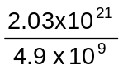= 4.15 x 10¹¹ years  [1]
 | (d) | Suggest a possible challenge faced by the world in methane hydrate exploration  The methane hydrate is found 500 to 2000 m below the ocean surface; thus, advanced machinery is required to obtain the methane hydrate.  [1]
 | (e) | Suggest a reason why hydrocarbons form hydrates less readily as the molecule length increases.  As molecular length of the hydrocarbon chain increases, it becomes difficult for it to pack within the spaces in the crystal structure of water. As the hydrocarbon chain is hydrophobic, it is also unable to form favourable interactions with water.  [1]
 | (f) | Calculate the amount of energy that can be produced from 1 m³ of water gas.  1 m³ of water gas contains 500 dm³ of CO and 500 dm³ of H₂.  No. of moles of H₂ and CO = 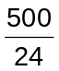= 20.8 moles  Energy evolved = 20.8 (242 + 283) = 1.09 x 10⁴ kJ  [2]
 | (g) | Suggest two reasons why methane is used as a preferred fuel compared to water gas in industries.  Methane gives out more energy per m³ and methane does not contain the toxic CO found in water gas.  [2]  [Total:10]

Section B

Answer two of the following three questions. Answer these questions on separate answer paper.

1 | Butane can react with Cl₂(g) to form monochlorinated butane.
 | (a) | (i) | Name the type of reaction and state the condition required for the reaction to occur.  Free radical substitution. Heat or uv light is required.
 |  | (ii) | Draw the structures of all the possible monochlorinated butanes formed.  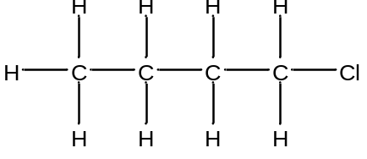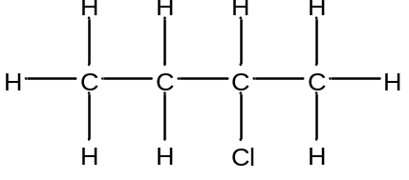
 |  | (iii) | State and explain the ratio in which they are formed.  1-chlorobutane: 2-chlorobutane is 3:2 as there are 6 hydrogen atoms that could be replaced to form 1-chlorobutane but only 4 hydrogen atoms that could be replaced to form 2-chlorobutane.  [6]
 | (b) | The rate for the reaction between chlorobutane and aqueous sodium hydroxide was studied using two solutions of different initial concentrations of sodium hydroxide and the same initial concentration of chlorobutane. The results are as shown below:  (i) Plot these data on suitable axes.
  Time / min | Experiment 1 | Experiment 2
  Time / min | [Chlorobutane] / mol dm⁻³ when [NaOH] = 0.20 mol dm⁻³ | [Chlorobutane] / mol dm⁻³ when [NaOH] = 0.30 mol dm⁻³
  0 | 0.0100 | 0.0100
  40 | 0.0079 | 0.0070
  80 | 0.0062 | 0.0049
  120 | 0.0049 | 0.0034
  160 | 0.0038 | 0.0024
  200 | 0.0030 | 0.0017
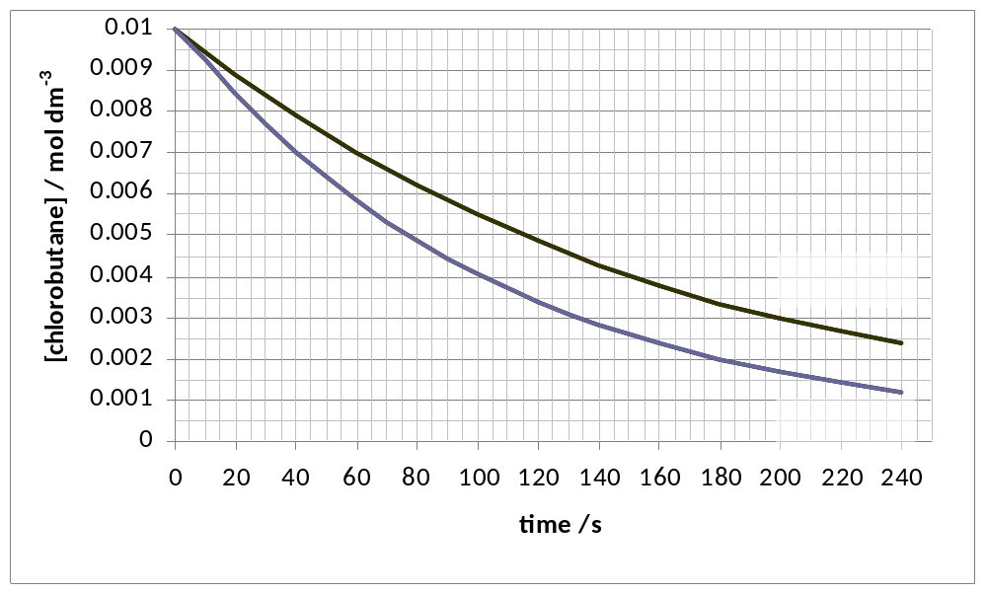

77.5s
155 – 77.5 = 77.5 s

 |  | (ii) | From the graphs, deduce the order of reaction with respect to chlorobutane and aqueous sodium hydroxide.  Chlorobutane: constant t1/2 of 77.5 s, thus first order.  Expt 1: 0.20 mol dm⁻³ NaOH, R = 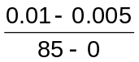= 5.88 x 10⁻⁵ mol dm⁻³ s⁻¹  Expt 2: 0.30 mol dm⁻³ NaOH, R = 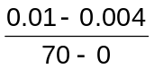= 8.57 x 10⁻⁵ mol dm⁻³ s⁻¹  When [NaOH] increase 1.5 x, R increase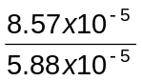= 1.46 x  1st order wrt NaOH.
 |  | (iii) | Hence, deduce the rate equation and calculate a value for the rate constant, stating its units.  R = k[NaOH][chlorobutane]  k = 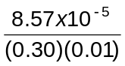= 0.0286 mol⁻¹ dm³s⁻¹  [6]
 | (c) | With the aid of a relevant diagram, explain how an increase in temperature will increase the rate of the above reaction.  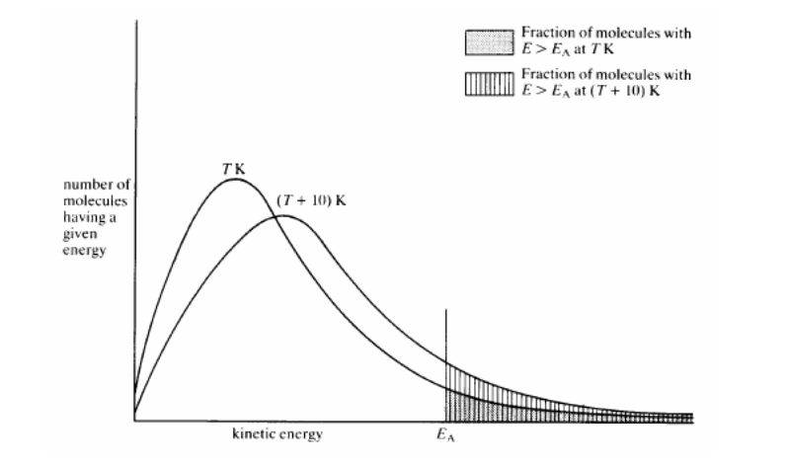  Temperature increase, there will be a greater fraction of molecules with energy greater than activation energy, thus more effective collisions leading to a greater rate of reaction.  [3]
 | (d) | The table below shows the pH values of Period 3 chlorides in water.
  Period 3 chloride | pH of a 1.0 mol dm⁻³ solution in water at 25ºC
  NaCl | 7.0
  MgCl₂ | 6.5
  AlCl₃ | 3.0
  SiCl₄ | 2.0
  PCl₅ | 1.0 - 2.0
 |  | (i) | By writing relevant balanced equations, explain the difference in pH of aqueous solutions of NaCl, AlCl₃ and PCl₅.  NaCl + aq → Na⁺ + Cl⁻  Na⁺ has low charge to volume ratio than Na⁺, thus cannot polarize water to give H⁺. Thus, solution is at pH 7.  AlCl₃ + 6 H₂O → [Al(H₂O)₆]³⁺ + 3 Cl⁻  [Al(H₂O)₆]³⁺ + H₂O[Al(H₂O)₆OH]²⁺ + H₃O⁺  Al³⁺ has higher charge to volume ratio than Na⁺, thus polarize water causing O – H bond to break and give H⁺. Thus, solution is at pH 3.  PCl₃ + 3 H₂O → H₃PO₃ + 3 HCl  PCl₃ hydrolyses in water to form a strong acid HCl of pH1.0 to 2.0.
 |  | (ii) | Using the information given in the above table and the Data booklet, predict with explanations, the pH value of a 1 mol dm⁻³ solution of BeCl₂.  Be²⁺ has the highest charge to radius ratio, thus would polarize O – H bonds of water to greater extent, leading to more H⁺ produced, pH = 2.5  [5]  [Total: 20]
  ion | 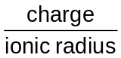
  Na⁺ | 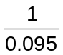= 10.5
  Be²⁺ | 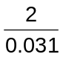= 64.5
  Al³⁺ | 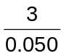= 60.0

2 | At room temperature, dinitrogen tetraoxide dissociates and forms an equilibrium with nitrogen dioxide in a closed vessel, as shown in the equation below.  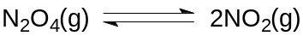)  Pale yellow Dark brown
 | (a) | (i) | Draw the dot-cross diagram of N₂O₄ & NO₂.  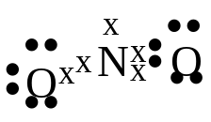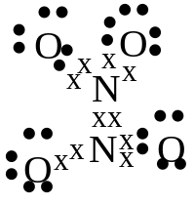  Bent trigonal planar
 |  | (ii) | Hence state and explain if the forward reaction is endothermic or exothermic.  Forward reaction is dissociation, breaking of N – N bond, thus is endothermic.  [3]
 | (b) | (i) | At 1400°C, 3 moles of N₂O₄ was placed in a 2 dm³ vessel and allowed to reach equilibrium. At equilibrium, 60% of the N₂O₄ dissociated into NO₂. Calculate the equilibrium constant, K_{c} at this temperature, stating its units.  Amt of N₂O₄ dissociated = 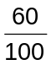x 3 = 1.8  N₂O₄ (g)  2NO₂ (g)  Initial amt 3 0  Change - 1.8 +2(1.8)  Final amt 1.2 3.6  [ ]/moldm⁻³ 0.6 1.8  K_{c} = 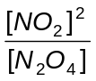= 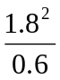=5.4 mol dm⁻³
 |  | (ii) | State and explain the expected colour of the equilibrium mixture in the vessel when  - the volume is increased to 4 dm³  - the vessel is immersed in a beaker containing hot water.  (I): equilibrium shifts to the right to less moles of gas by Le Chatelier’s principle to partially reduce pressure. More NO₂ form, thus is darker brown.  (II): equilibrium shifts to the right to favour forward endothermic reaction by Le Chatelier’s principle to partially reduce the temperature by absorbing the excess heat. More NO₂ form, thus is darker brown.  [7]
 | (c) | (i) | At 1400°C, the activation energy for the forward reaction is 150 kJ mol⁻¹ and that for the reverse reaction is 91.3 kJ mol⁻¹. Sketch a reaction pathway diagram for this reaction.  Energy/ kJ mol⁻¹  E_{a}(f) = 150 kJmol⁻¹  E_{a}(b) = 91.3 kJmol⁻¹  E_{a}(b) catalysed = 60.3 kJmol⁻¹  ΔH = +58.7 kJmol⁻¹
 |  | (ii) | Hence determine the value of the enthalpy change of dissociation of N₂O₄.  ΔH = +58.7 kJmol⁻¹
 |  | (iii) | In the presence of a catalyst, the activation energy for the reverse reaction is 60.3 kJ mol⁻¹. On your sketch in c(i), draw the energy profile of the catalysed reaction. Suggest a value for the activation energy for the dissociation of N₂O₄ under these conditions.  E_{a} = 58.7 + 60.3 = 119 kJ mol⁻¹  [5]
 | (d) | The oxides of Period 3 elements differ considerably in their physical and chemical properties.
 |  | (i) | State the formulae of the oxides formed by sodium, aluminium and phosphorus.  Na₂O, Al₂O₃, P₄O₁₀
 |  | (ii) | Explain the acid-base nature of these oxides in terms of their structures and bonding. Hence write equations for the reactions, if any, of oxides of these elements with aqueous alkali and acid.  Na₂O is an ionic oxide, thus is a basic oxide and thus react with acids  e.g. Na₂O + 2 HCl → 2 NaCl + H₂O  Al₂O₃ is amphoteric as it is ionic with covalent character, thus react with both acid and alkali  e.g. Al₂O₃ + 6 HCl → 2 AlCl₃ + 3 H₂O  Al₂O₃ + 2 NaOH + 3 H₂O → 2 NaAl(OH)₄  P₄O₁₀ is a covalent compound and is thus an acidic oxide. Thus it reacts with a base.  P₄O₁₀ + 12 NaOH → 4 Na₃PO₄ + 6 H₂O  [5]  [Total: 20]

3 | (a) | A compound E has the following composition by mass:  C: 29.3% H: 5.70% Br: 65.0%  Heating E in the presence of ethanolic KOH forms F.  F can decolourise Br₂ in CCl₄. F can also react with gaseous HBr to form E and G.  G forms H when heated with aqueous NaOH. When compound H is reflux with acidified K₂Cr₂O₇, J is formed. Both compounds H and J give a yellow precipitate when warmed with alkaline I₂(aq).  White fumes are observed and compound K is formed when SOCl₂ is added to H.  K reacts with ethanolic KCN to form compound L which when heated in the presence of dilute HCl forms M.  M and H are heated in the presence of excess concentrated sulfuric acid forms N.  Deduce the structures of compounds E to N, explaining the chemistry for the reactions involved. Write equations where appropriate.  [15]
Reaction | Deduction
Compound E  C:29.3% H:5.70% Br:65.0% | Empirical formula = C₃H₇Br  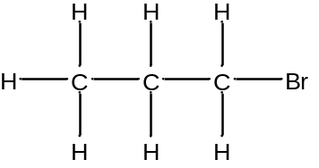  Compound E
   | C | H | Br
  % by mass | 29.3 | 5.70 | 65.0
  A_{r} | 12.0 | 1.0 | 80.0
  Mole | 2.44 | 5.70 | 0.8125
  Ratio | 3 | 7 | 1
Heating E in the presence of ethanolic KOH forms F. | E undergoes elimination of HBr to form an alkene F.  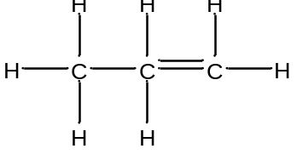  Compound F
F can decolourise Br₂ in CCl₄. | Electrophilic addition of Br₂ across C=C
F can also react with gaseous HBr to form E and G | F undergoes electrophilic addition with HBr to give E and G  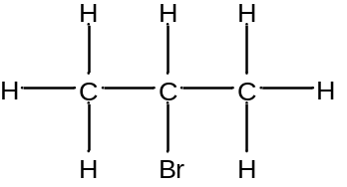  Compound G
G forms H when heated in aqueous NaOH. | Nucleophilic substitution of G to give H, an alcohol.  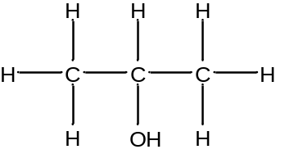  Compound H
When compound H is reflux with acidified K₂Cr₂O₇, J is formed. | Oxidation of alcohol H. H is not a tertiary alcohol.
Both compounds H and J give a yellow precipitate when warmed with alkaline I₂(aq). | H is a methyl alcohol (secondary alcohol), J is a methyl ketone.  Compound H  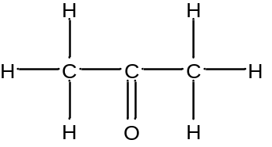  Compound J
White fumes are observed and compound K is formed when SOCl₂ is added to H. | K is a chloroalkane, substitution of –OH for –Cl occurred.  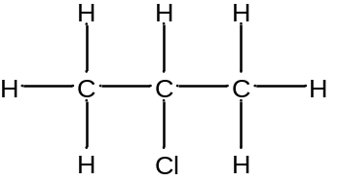  Compound K
K reacts with ethanolic KCN to form compound L which when heated in the presence of dilute HCl forms H. | Nucleophilic substitution of –Cl with –CN. L is has –CN group, undergoes hydrolysis with hot HCl(aq) to give H, -COOH group formed.  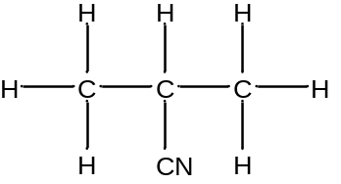  Compound L  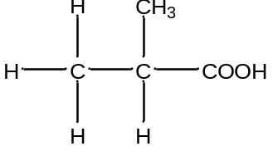  Compound M
M and H when heated in the presence of excess concentrated sulfuric acid forms N. | M is acid, H is alcohol. Esterification occurred. N is an ester.  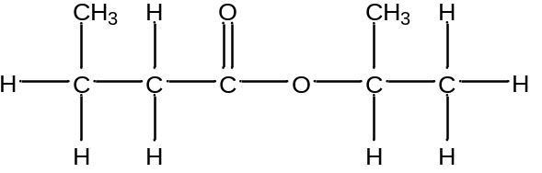  Compound N

 | (b) | Suggest the reagents and conditions used for the following synthesis and draw the structures of the intermediates formed in the reaction.
 |  | (i) | 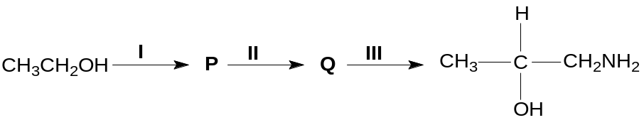  I: K₂Cr₂O₇, H₂SO₄ (aq), heat with distillation  II: KCN, HCl, trace of NaCN as catalyst, cold  III: LiAlH₄ dry ether  P = CH₃CHO  Q = CH₃CH(OH)CN
 |  | (ii) | 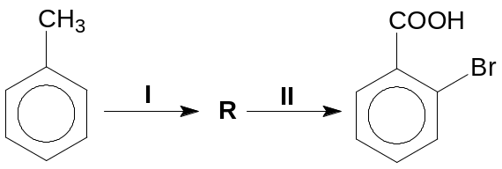  I: Br₂, AlBr₃, dark  II: KMnO₄, dilute H₂SO₄, heat  R =  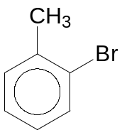  [5]  [Total: 20]

